**AI-Powered Personal Tutor: A Scalable, Adaptive Learning System for Enhanced Student Engagement**

**1. Abstract**

The educational landscape is undergoing a significant transformation, driven by the increasing recognition of personalized and adaptive learning methodologies. These approaches cater to the diverse needs of students, fostering a more engaging and effective learning environment. This report details the development of an AI-Powered Personal Tutor application, a cutting-edge system designed to enhance student learning within the K-12 educational framework. By harnessing the power of Retrieval Augmented Generation (RAG), the application delivers personalized, contextually relevant answers to student queries, drawing from a comprehensive syllabus and user-uploaded documents. Adaptive learning mechanisms play a crucial role in tailoring the complexity and language of responses, dynamically adjusting to the student's grade level and performance. Key features include seamless document upload, interactive question answering, automated grade-appropriate quiz generation, precise performance tracking, and personalized feedback, all presented through an intuitive and user-friendly Streamlit interface. This application aims to address the critical need for personalized, scalable, and engaging learning experiences, aligning with established educational standards and ultimately fostering improved student outcomes.

**2. Introduction**

In the contemporary educational paradigm, personalized and adaptive learning approaches are gaining paramount importance as essential components for fostering effective education within diverse learning environments. Traditional educational models, often characterized by a uniform instructional approach, frequently fall short in addressing the varied needs, distinct learning styles, and individual paces at which students acquire knowledge. Artificial intelligence (AI) has emerged as a powerful catalyst in this context, offering a range of sophisticated tools and innovative techniques that can facilitate the creation of truly personalized and adaptive learning experiences for students. Among the notable advancements in this domain are AI-powered intelligent tutoring systems (ITS), which leverage AI to deliver instruction that is tailored to the individual learner, provide feedback in real time, and adapt content to suit specific learning requirements. Recent trends within the education sector indicate a growing inclination towards the adoption of AI technologies, accompanied by positive perceptions from both educators and students regarding the potential of AI to significantly enhance the overall learning process.

**3. Problem Statement**

Traditional educational models often struggle to provide personalized learning experiences that cater to the diverse and unique needs of students. Students possess distinct learning styles, varying paces of comprehension, and specific areas of strength and weakness. Existing educational resources may not effectively address these individual differences, leading to disengagement, frustration, and ultimately, reduced learning outcomes. There is a critical need for an adaptive and scalable system that can provide personalized learning experiences, meticulously tailored to the student's grade level and performance, while also providing seamless access to relevant educational content. Additionally, students often require support in understanding complex topics and need access to resources that can provide contextually relevant answers to their specific questions, drawing from both established curricula and supplementary materials.

**4. Proposed Solution**

The proposed solution is an AI-Powered Personal Tutor application, a sophisticated system designed to enhance student engagement and academic performance. This application will leverage Retrieval Augmented Generation (RAG) to provide contextually relevant and grounded answers to student questions, drawing from both a comprehensive K-12 syllabus and user-uploaded documents. The system will incorporate adaptive learning mechanisms, intelligently tailoring the language and complexity of responses to the student's grade level and performance on generated quizzes. The application will feature an intuitive and user-friendly interface developed using the Streamlit framework, ensuring accessibility and ease of use for students of all ages and technical proficiencies.

Key Components and Functionalities:

* **Document Upload:** Enables students to upload PDF documents, expanding learning resources beyond the core syllabus. LangChain loaders (PyPDFLoader, PyMuPDFLoader, UnstructuredPDFLoader) facilitate efficient processing, ensuring seamless integration of diverse learning materials.

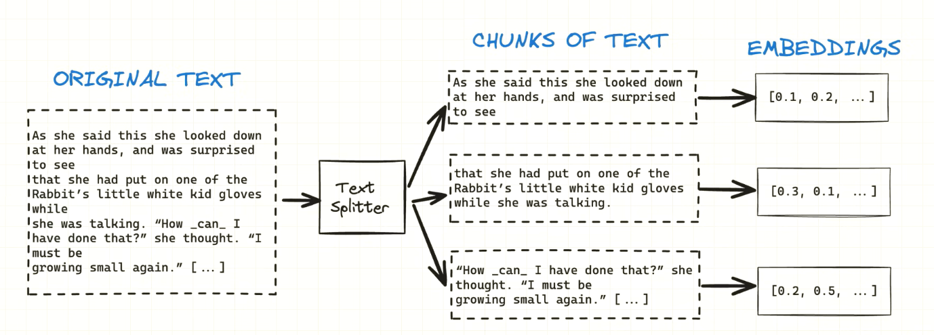

* **Syllabus Integration:** Utilizes vector embeddings of the complete K-12 syllabus, stored in ChromaDB, as a primary and authoritative information source. Nomic Embed Text 1.5 (Sentence Transformers) generates highly accurate embeddings, enabling efficient semantic search and retrieval.

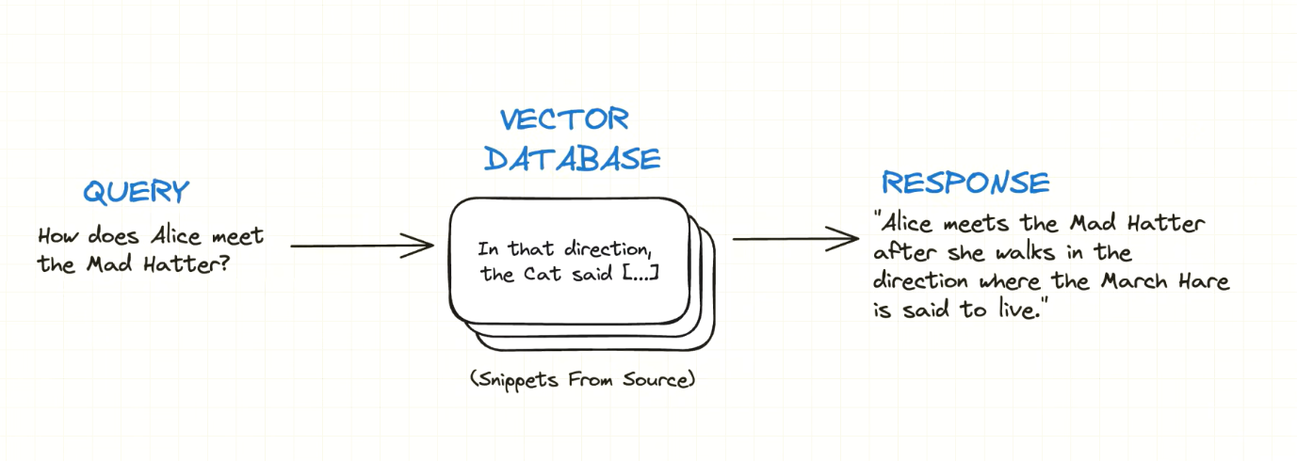

* **Adaptive Learning:** Employs sophisticated algorithms to modify LLM prompts (Llama 3), dynamically adjusting response complexity and language based on the student's grade level and performance on generated quizzes, ensuring optimal comprehension and engagement.
* **Quiz Generation:** Generates grade-appropriate practice questions using the LLM, meticulously tailored to curriculum content and cognitive levels, providing students with valuable practice and assessment opportunities.
* **Document Q&A:** Answers student questions based on both uploaded documents and the syllabus, utilizing cosine similarity for semantic retrieval and Llama 3 for accurate and comprehensive response generation.
* **Re-ranking:** Improves the relevance and accuracy of answers by implementing cross-encoder models from Sentence Transformers, ensuring that students receive the most pertinent information.
* **User Interface:** Provides an intuitive and user-friendly Streamlit interface, featuring seamless file upload, grade selection, text input, and clear output display, ensuring accessibility and ease of navigation.
* **Performance Tracking and Feedback:** Tracks student quiz performance and provides personalized feedback, empowering students to monitor their progress and identify areas for improvement.

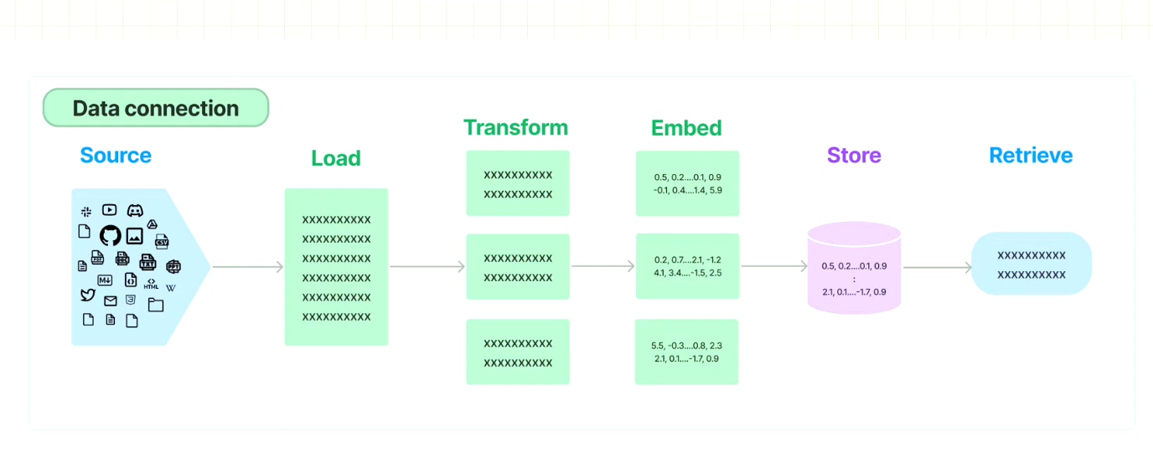

**Technology Utilization Table:**

|  |  |
| --- | --- |
| **Functionality** | **Technology Used** |
| Document Upload | Streamlit (st.file_uploader) |
| Document Processing | LangChain (PDF Loaders), Python PDF Utilities |
| Text Chunking | LangChain (CharacterTextSplitter) |
| Vector Database | ChromaDB |
| Embedding Generation | Nomic Embed Text 1.5 (Sentence Transformers) |
| Semantic Retrieval | ChromaDB, Cosine Similarity |
| LLM Integration | Ollama SDK, Llama 3 |
| Response Generation | Llama 3 |
| Re-ranking | Sentence Transformers (Cross-Encoders) |
| User Interface | Streamlit |
| Dropdown Menu | Streamlit (st.selectbox) |
| Text Input | Streamlit (st.text_input) |
| Output Stream | Streamlit (st.write, st.dataframe) |
| Performance Tracking | Streamlit (Session State), Python Logic |
| Feedback Provision | Streamlit (st.write, st.success) |

**5. Workflow**

The application's workflow is designed to be intuitive and user-friendly, guiding students through a structured and engaging learning experience. The process begins with the user selecting their current grade level, establishing a crucial baseline for personalization. A pre-assessment quiz is then administered to evaluate the student's existing knowledge base, providing the system with valuable insights into their current level of comprehension. Subsequently, the system analyzes the student's performance score on the pre-assessment, in conjunction with their declared grade level, to dynamically tailor the output language and the overall complexity of the information presented. Users can then ask questions related to the learning material, with the system retrieving relevant context from both the syllabus and uploaded documents. The LLM generates comprehensive answers, providing source information for transparency and credibility. Users can also upload their own PDF documents and generate practice quizzes based on the content. Throughout the learning process, the system continuously tracks quiz scores and provides personalized feedback, empowering students to monitor their progress and identify areas for improvement.

**6. Outputs**

The application provides the following key outputs:

* **Contextually Grounded Answers:** Accurate and relevant answers based on the syllabus and uploaded documents.
* **Grade-Appropriate Quizzes:** Tailored quizzes that align with the student’s grade level.
* **Performance Tracking and Feedback:** Real-time feedback and progress monitoring.
* **Source Information:** Clear display of source documents and text chunks.
* **Adaptive Responses:** Dynamically adjusted language and complexity.

**7. Conclusion**

The AI-Powered Personal Tutor application represents a significant advancement in leveraging AI to enhance educational experiences. By combining sophisticated document retrieval and LLM capabilities, the application offers personalized learning through adaptive mechanisms. Its scalability and adaptability address the diverse needs of K-12 students, promising a transformative impact on education.